Dear Parents and Carers, 8th March 2024

Student Leaders at Churchill have been investigating the use of plastic, how we have become so dependent on it in our everyday lives and the impact this has on our Environment. We have been looking at how we can raise awareness of this and try to make a positive change. For this reason, we have decided to take part in "The Big Plastic Count" and would really like you to get involved as well. Together, we can build even more evidence about what happens to our plastic waste to help put a stop to the plastic crisis.

In 2022, nearly 250,000 people from schools, households and communities across the country made The Big Plastic Count the biggest ever investigation into UK household plastic waste. It showed that nearly 100 billion pieces of plastic are thrown away in the UK each year, with hardly any of it recycled.

The rest is burned, sent abroad or ends up in landfill. We can’t recycle our way out of the plastic waste crisis, so The Big Plastic Count is back – and this time we’ve got an even bigger target in our sights – The Global Plastics Treaty.

By joining thousands of people across the country and counting all the plastic you throw away for a week, you can gather the vital evidence we need to convince UK ministers, supermarkets and big brands to lead the way at the global talks that could finally phase out plastic production for good.

Let’s get counting to make the Global Plastics Treaty as big and bold as it can be.

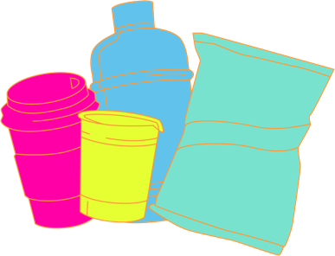
The UK Government needs to push for a strong and ambitious Global Plastics Treaty. The treaty needs to include an end to plastic pollution, a phase-out of new plastic production, and ensure a just and inclusive transition to a low-carbon, zero-waste, reuse-based economy.

This isn’t about rating anyone’s recycling habits, and we wouldn’t want anyone to feel embarrassed by how much plastic they use. We know that there are some plastic items which are essential for disabled people, or people with medical conditions, and so these won’t be included in the count.

HOW TO TAKE PART

It’s easy! From Monday morning until Sunday evening, count as you throw!
Simply mark every piece of plastic package as you throw it away on the Let’s Count Tally Sheet.

TOP TIPS

- Put the Let’s Count Tally Sheet up on your fridge, or near your bin or recycling.
- Tell everyone you live with that you’re going to be taking part and ask them to include their plastic waste in the count too.
- Using the Let’s Count Tally Sheet, record the different types of household plastic packaging waste you use for one week. This includes plastic going in your bin and plastic you put out for recycling.
- Use the Plastic ID Tool to look up plastic items if you need to.
- Remember to write down any piece of plastic packaging you use while out and about, then mark it on your tally sheet when you get back home.

WHAT NOT TO COUNT

- Don’t include: plasters, medication packaging, non-dairy milk/juice cartons, nappies, dog poo bags, plastic cutlery or period products.
- We don't want to include plastic items that are used for medical or sanitary reasons, or by people with disabilities who rely on plastic items for independence.
- Also, we are not counting coffee cups or Tetra Pak, the plasticised cardboard material that many juice/milk cartons are made of.
- Check out the Plastic ID Tool online to familiarise yourself with the kinds of plastics we’re counting up for this survey.

Once your household has completed the survey, your child should record their results online at home via our unique class link.
https://thebigplasticcount.com/submit/3098/churchill-academy-and-sixth-form

Find out more about The Big Plastic Count here: thebigplasticcount.com.
We’d like to say a huge thank you for taking part in this important investigation!
Together, we can build even more evidence about what really happens to our plastic.

Best wishes,

The student sustainability team.

